**Tutorial on obtaining tweets:**

**Part 1: Create Twitter API Token and Secrets**

**1. Go to** <https://developer.twitter.com/en.html>, and log in with a twitter account

**2. Go to the app page through here:**

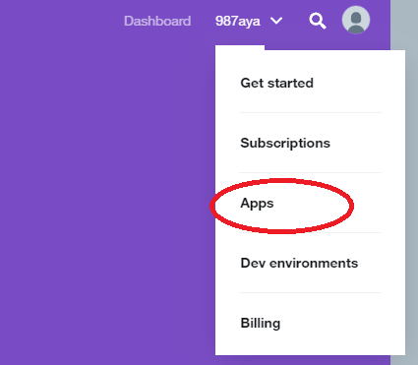

**3. Click the button Create an app**



**4. Fill out required information. For website URL, fill in** [**https://www.uofl.edu**](https://www.uofl.edu)**. You can leave callback URL blank and all other non-required fields blank.**

**5. Click create, an app summarization page will be shown:**

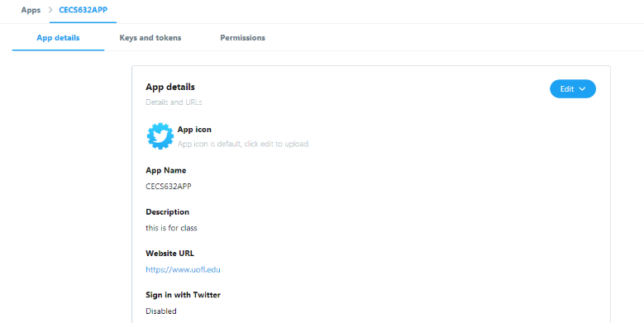

**6. Click on Keys and Tokens on the summarization page**

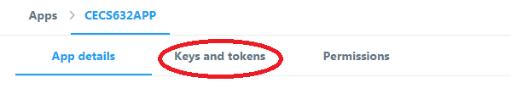

**7. You should see Consumer API Keys. Access tokens are empty but you can create them by click on create button. You will need these 4 strings for part 2.**

**Part 2: Getting Tweets**

**1. Most PC, Mac and Linux have python pre-installed. If you don’t have python, please contact TA**

**2. On Windows open command prompt (cmd), on Linux and Mac open terminal**

**3. Check if pip is already installed with your python by typing *pip –version in cmd or terminal.* If pip is not installed, follow instruction here:** <https://pip.pypa.io/en/stable/installing/>

**3. Install tweepy by typing command *pip install tweepy***

**4. Open tweets.py (found under Project 1 on blackboard) with plain text editor (such as notepad, notepad++ or TextEdit). Please do not use Word or other advanced text editor since those programs add extra things to the file. Replace the access_token, access_token_secret, consumer_key, consumer_secret with the 4 strings from the twitter app page.**

**5. Replace the keyword to track at line**

***stream.filter(track=['football', 'soccer', 'FIFA'])***

**You can enter up to 500 key words.**

**6. Run tweets.py. Go to command prompt (cmd) or terminal. Go to the folder where tweets.py is saved. and type *python tweets.py*. You should start to see tweets flow in. The tweets are in JSON format. Stop the program by press Ctrl-C.**

**7. To capture these tweets in a file, when you run tweets.py, type *python tweets.py > tweets.txt* . Now all the tweets will be stored in tweets.txt for later parsing and analysis**

**Part 3: Parse Tweets From JSON to CSV**

**1. Install package unicodecsv by typing *pip install unicodecsv* in cmd or terminal**

**1. Download tweetparser.py from Project 1 on blackboard.**

**2. Make sure your raw tweet file is in the same folder as tweetparser.py.**

**3. Run *python tweetparser.py [input_file_name] [output_file_name]*, where input_file_name is your raw tweet file and output_file_name is the parsed tweet.**

**4. Check your CSV. Inside there is a column called “user”. All the information in that column is extracted to the end of the CSV columns with column name start with “user_”. There are several other columns not extracted. If you need them to be extracted, please contact the TA.**